Backyard Science Projects
EPY 370
Spring 2011

Introduction
This spring, Principal Gregory Jones and first grade teacher Mrs. Rodriguez have asked for support in creating hands on science projects for students. By visiting the school and helping carry out these projects, you will be doing what is called “Service Learning.” Service learning is learning that grows out of real world purposes and fills real world needs. Many parents of children at New Scotland Elementary School have asked to see more hands on learning at the school. What you do this semester could change the school culture by inspiring other teachers and empowering parents to ask for more hands on learning experiences. By helping the children with these projects, you will be able to process our course concepts more deeply and link them to real experiences and real learners. You can also put on your resumes that you participated in a “Service Learning Grant,” through Project SLATE (“Service Learning and Teacher Education”), funded by a grant through the federal Corporation for National and Community Service.
All in all, I think you will find these activities enrich your learning and are also fun and meaningful.
In this short packet, you will find the guiding principles of the projects as well as details of what you will do. The activities are spelled out for you, so that you can do them easily and spend a great deal of your time and energy observing and interacting with the children.

Guiding principles
Service Learning
Not only are you doing service learning by working in the school, the children are also doing service learning. The projects all aim to get children to observe more closely and reflect on their immediate environment and community, and our final project of creating food garlands for animals serves the local library, its patrons, and “animal allies” in the city.
Connecting to nature
Urban and suburban children today spend very little time in nature. Some facts may astound you. These are from the National Wildlife Federation’s “Be Out There” pages (http://www.nwf.org/Get-Outside/Be-Out-There/Why-Be-Out-There.aspx):
- Children are spending half as much time outdoors as they did 20 years ago. (Juster et al 2004); (Burdette & Whitaker 2005); (Kuo & Sullivan 2001)
- Today, kids 8-18 years old devote an average of 7 hours and 38 minutes using entertainment media in a typical day (more than 53 hours a week). (Kaiser Family Foundation, http://www.kff.org/entmedia/mh012010pkg.cfm )
- In a typical week, only 6% of children ages 9-13 play outside on their own. (Children & Nature Network, 2008)
- Children who play outside are more physically active, more creative in their play, less aggressive and show better concentration. (Burdette and Whitaker, 2005; Ginsburg et al., 2007)
- Sixty minutes of daily unstructured free play is essential to children’s physical and mental health. (American Academy of Pediatrics, 2008)
- The most direct route to caring for the environment as an adult is participating in “wild nature activities” before the age of 11. (Wells and Lekies, 2006)

These facts suggest that children of all ages are in dire need of activities that awaken a curiosity about and love of nature, natural materials (rock, soil, water, plants, animals), and phenomenon (wind, weather). The projects all aim for this. And we will get outside, too!

Developmentally appropriate practice
When we teach, we always keep in mind learner’s developmental stages. In early middle childhood, children think concretely. To learn about rocks, it is best to look at, touch, and manipulate rocks. Children also learn through fantasy and role play. If we are learning about wind, children can pretend they are the sun, the land, and the sea. Hands can show the sun’s heat moving down, and other hands can show some air rising fast from the sea, and some air rising slowly from the land. As the children’s hands move about (waving), they will feel air being pushed about. They can imagine what it is like to be air rushing around the earth as wind. Children also learn through talking, so asking them to describe their ideas and imaginations can fuel their thinking. Guiding these burgeoning scientific thoughts is also part of their development. Children in middle childhood also love to draw, love to explore small spaces, and love to have adventures. The projects all involve these principles.
Listening for scientific ideas in children’s talk
As you may know, children love to talk! And, they say “the darndest things”! Their explanations of scientific (or more simply put, formal) understandings are often very funny, interesting, and unique. But there is usually something very scientific and precise about their talk, even if it doesn’t sound scientific. For example, when a child says that the rock cycle is “Soil, sand, clay—I think it’s clay—and then gravel” they do not show that they understand the notion that rocks are formed through a cycle involving volcanic rock and subsequent forces, but they are showing an understanding of layers in earth as well as the notion that their ideas may be faulty. These are places to open into and guide these emerging scientific ideas.
Listening for, eliciting, and recording children’s ideas, questions, and new understandings is a guiding principle for our projects.

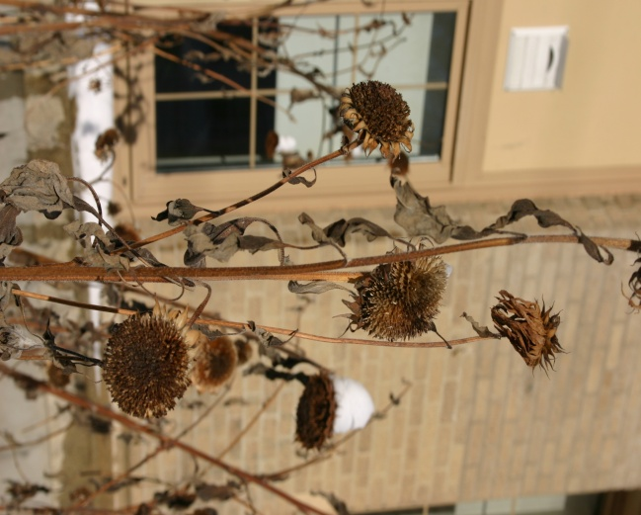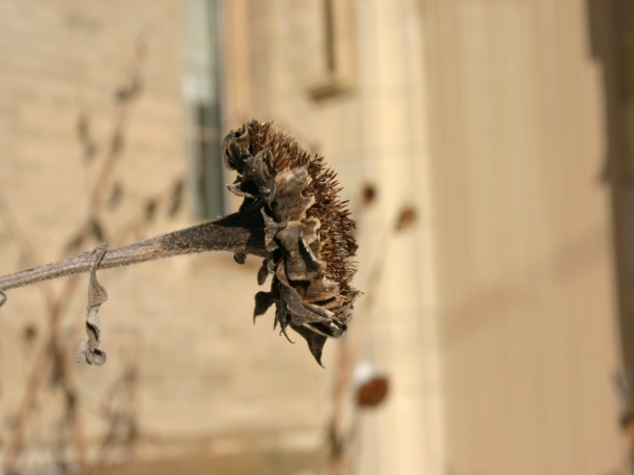
Keep these four guiding principles in mind as you do the projects with the children. Below you will find a description of each project and the activities involved for each project. There is also some general information about the topics. The projects are linked to State and District Standards. The projects are linked to the Harcourt Science Curriculum topics of Earth’s Land, Our Natural Resources, Measuring Weather, and The Sky and the Seasons.
Before we start these projects with the children, they will be introduced using the books Secret Place by Eve Bunting.
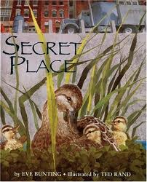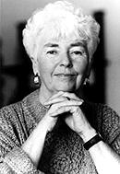

I have included all the projects in this packet for you, but you will find your particular team’s projects marked clearly! Have fun! Remember to read the Guiding prompts so that you have some ideas about what to look for and what to journal about!

Project 1: Making a Fossil (Team 1)
Learning Goals: Children will learn about how fossils are formed. Children will be learning about fossils, specifically that they are parts and imprints of a plant or an animal that lived long ago. They will be learning the concept that animals and plants can become extinct. Here is a short excerpt from the teacher’s Harcourt Science Curriculum Guide:
“Formation of Fossils: Fossils form in a variety of ways. The starfish fossil on page C10 was formed as the animal sank and became covered with mud and sediment, which protected it from the natural processes of decomposition. Over time the sediment containing the starfish became deeply buried. Under pressure, the sediment and rock were replaced by minerals, such as silica, and the original matter from which the starfish was formed dissolved, leaving an imprint or cast in the surrounding rock. Fossils also may form as the porous parts of bone or other matter fill with minerals from groundwater. The minerals keep the bone from coming in contact with air and make it stonelike. Another type of fossil may form in the resin of ancient conifer trees. Insects or parts of other animals may become trapped in the resin. As the resin hardens into amber, the animal becomes a fossil.” (p. C9)
Behavioral goals: The children will make a fossil. Each child will mix sand (1/4 to ½ a cup) and glue in a small container or on a piece of wax paper. The proportion should be about 1 part sand to 1.5 parts glue, but I strongly suggest you try it first and see how it works as glues and sands tend to be different. Then they will choose an object to coat completely with petroleum jelly and press it firmly into the mixture. The sand/glue mixture will need to dry. They will gently remove the object.
Meeting 1 (Monday, January 31)
Children will make their fossil. Before they start, help them to imagine the process of something being buried and under pressure. You can use hands or a pile up of legs to do this. Alternately you can have them imagine what the earth was like when dinosaurs lived. As they make the fossil, have them imagine that the glue/sand mixture is a mudslide, mud slowly covering the object they’ve chosen, or sap oozing around an insect. Encourage them to say what this event might have sounded like, felt like, or even smelled like!
Meeting 2 (Wednesday, February 2)
If they haven’t already, children will remove the object used to make the impression or “fossil” they made on Monday. Have them compare the texture of the object and the markings in the sand/glue mixture. What has changed? Why? What showed up well? Why? What do scientists who study fossils do when they see only part of a plant or animal that is fossilized? Have students draw their fossil in their science journal and label parts. Ask them to imagine if the fossil is stone, minerals, or amber and have them write down one or two words labeling the material and their fossil. Be sure they add the full date to their drawing.

Project 2: Making a Rock Shadow Box (Team 2)
Learning Goals: Children will observe, sort, and classify rocks. They will focus their senses on color, texture, size, shape, weight, and even smell. They will be encouraged to think about ways to organize rocks according to their own classification systems (where they were found or who gave them to the child), but also in terms that are more scientific. Children will be learning that rocks are hard and nonliving. They will be learning that rocks come from mountains and that people and other forces break them into smaller and smaller rocks. They are also learning about the uses of rocks. You can do some research on the rock cycle if you like! Here is a short excerpt from the teacher’s Harcourt Science Curriculum Guide:
“Earth’s crust is made of three different groups of rocks. Igneous rocks form when molten rock such as magma or lava cools. Granite and basalt are types of igneous rocks. Sedimentary rocks form when sediments are cemented together or when chemicals precipitate from ocean water. Sandstone, limestone, and shale are types of sedimentary rock. Metamorphic rocks form when any type of rock is subjected to enough heat and pressure to change it without melting. Slate and marble are types of metamorphic rock. Most kinds of rocks can easily be found in one region of the world or another. People use rocks for building roads and structures, as well as for jewelry and other projects, including materials such as chalk.” (p. C5)
Behavioral Goals: Each child will build a shadow box (which is simply another name for a display box), using a shoebox and the tops and bottoms of cardboard jewelry boxes. They will glue the smaller boxes into the shoe box, affix rocks using modeling clay, and label their rocks.
Meeting 1 (Monday, February 7)
Children will assemble their rock collection, from both their own rocks they bring in and from some that will be provided. As they show the others in the group their rocks, ask them where the rocks came from or where they think they came from. Encourage students to describe these places in detail. Ask them about how the rocks are formed. Encourage them to imagine the great heat and pressure that took to form these rocks. Using magnifying glasses or a microscope (if we have access), they will each look carefully at one of their rocks. They should draw this rock in their science journal and carefully note in writing: size, shape, color, texture, weight (light or heavy) and place found (if they don’t know, encourage an imaginative response). Be sure they add a full date to their drawing.
Meeting 2 (Wednesday, February 9)
Children will build their shadow boxes. Help them glue smaller boxes into the larger shoe box. Remind them that they can add more boxes if their larger box doesn’t get filled. Using a blob of modeling clay, they will affix one or more rocks into each of the smaller boxes. In their science journal, have them write words to describe how the rocks in their collection look and feel. If there is time, they can draw their collection. Be sure they add a full date to their drawing.

Project 3: Soil Sampler (Team 3)
Learning Goals: Children will learn that soil is different from rock and learn about the ideal material for growing a plant like beans. Children will learn that the earth is made up of layers. Children will make predictions, make observations, and record findings. Children will be learning about rocks and also about natural resources (plants, animals, land, water, and air). As described in the teacher’s Harcourt Science Curriculum Guide: “Natural resources enable people to meet their need for food, water, oxygen, and shelter. Plants, for example support all other life on Earth, providing food for many animals” (p. C23). They are also learning about ways to take care of natural resources. You can do some research on soil, but the basics are that the four layers (from bottom up) are: bedrock, parent material, subsoil, and topsoil. Soil is made up of mostly water, air, rocks, minerals, nutrients, organic matter, and animals (microscopic and larger). Soil particles are: sand, silt, and clay. Soil in our schoolyard, backyards, and gardens is a combination of those types. For plants to grow, they need to exchange gases, so they need soil and a location where they can get water and air. (Remember that in order to sprout, most seeds do not need light but they do need warmth.)
Behavioral Goals: Each group of children will create a soil sampler, which is a visual display of different types of soil found in the earth’s crust. This sampler approximates what you would find in a backyard. The soil sampler will include seeds at each layer of soil. The children will water and observe which kind of soil and which depth is best for growing plants.
Meeting 1 (Monday, February 14)
Each group of children will have four filled and covered coffee canisters. Each container has one of the following materials in it: rocks, clay, sand, and topsoil. Ask the children if any of them garden or have family or friends who grow vegetables or flowers. If so, ask them what is in soil. What do they think they would find if they dug down into the school garden? What layers would they find? Shake the canisters and let the children listen to what they hear. Tell them that there are different parts of soil in each can. Ask them to guess what is inside of each can. Ask them why they have their answers. When you open the canisters, ask them if these are all kinds of soil. Ask them what they know about soil and see what misperceptions they have. Be sure to point out that soil is made of different sized, but tiny pieces of rock (plus all the goodies mentioned in the Learning Goals). Help them create their soil sampler, by layering rocks, clay, sand, and topsoil. Write the children’s initials on the underside of the jar before you start. As they work, have the children place one or two seeds with the rocks, two in the clay, two in the sand, and the rest on the topsoil. Be sure that the seeds are by the side of the jar, so that they can be observed as they grow. Sprinkle grass seed on top. Before they water their soil sampler, ask them if the water will make it all the way down to the rocks. Water and have the children tell what they see. Ask the children to predict which layer will be the best for the seeds. Have the children write down their prediction in their science journal. If there is time, have the children draw and label the four layers of soil in their science journal. Be sure they add a full date to their drawing. Remind them to water if their soil sampler looks dry.

Meeting 2 (Friday, February 18)
Well, four days have passed, and we may see some germination! If not, you can help them work more on their science journals, completing any tasks from Monday that didn’t get finished. If they have sprouted, have children check their predictions again and use the findings from the experiment to see if they were right or wrong. Ask them why we got the results we did. Have them write in their journal if their prediction was right or wrong. Make sure they understand that wrong predictions are very important for scientists. They can sketch the germinated seed if there is time. You may also ask them to imagine what it is like to be a seed, germinating, and growing tall. Have the children act this out, starting curled up in a ball. Ask them to imagine being a seed in the different layers of the soil sampler. Encourage them to use language to describe what they feel, taste, and smell.
The children will continue to water these soil samplers, so don’t worry if they haven’t germinated by the end of the week.

Project 4: Investigating Water through a Mini (Recycled!) Sprouthouse (Team 1)
Learning Goals: The children have recently planted seeds in different kinds of soil, so they have been learning about and experiencing soil. They have learned that seeds need water and air to sprout. They have been thinking about soil as a natural resource. For this project, the children will be learning about water as a natural resource and will also be learning about taking care of natural resources. The children will be learning about the different sources of fresh water (streams, rivers, lakes) and how humans need clean, fresh water for cleaning, washing, drinking, and cooking. They should also know that our animal allies need clean, fresh water, too. The children will learn how salt water becomes fresh, so they will learn about evaporation, water vapor, condensation, and the water cycle (which will be covered more fully later in their book). There will be two opportunities for prediction, observations, and recording of findings. They will be learning about the principles of “reuse, recycle, and reduce” to help save natural resources. Earlier this school year the children learned about eating sprouts, so this will be reinforced when (or if!) you taste the radish sprouts!
Behavioral Goals: The children will each make a mini sprouthouse from a recycled CD case and plant radish seeds in it. Each group will also create an experimental mini sprouthouse together to see how they can speed up or slow the growth of the radish seeds. Before their sprouthouse activity, the children will also conduct another experiment to see what happens when salt water evaporates and condenses. The children (and you!) will eat the radish sprouts if you like.

Meeting 1 (Monday, February 28)
“Ocean in a glass:” Studying evaporation, condensation, and the water cycle
(Materials needed for each table: 2 glasses, one marked SALT WATER; saran wrap; rubber band; some salt; a spoon; 2 q-tips for each child; a paper towel; a small container for you to dispose of q-tips and ice)
Ask students to imagine that they are a drop of water and show how they move on earth and in the sky. Let children explain how they are moving. Listen for their knowledge of evaporation, condensation, and of the relation between salt and fresh water. When each child has had a turn, ask the children how the salt water in the ocean becomes fresh water. Ask why we need fresh water. See if they understand that not only we need fresh water, but also the plants and animals that sustain us. Explain that we are going to see how salt water becomes fresh and do an experiment to prove it to ourselves.
Tell the children that we are making the ocean in a glass. Let the children know that they must be very still and gentle or the experiment will not work. It is important that they understand that their behavior must be very good or we won’t be able to see the water cycle happen! If you like, you can also tell them that they will get to read a book with you after the experiment, but only if they are really good, calm, and gentle scientists who pay careful attention.
Children will make salt water in their groups by pouring salt into one glass with warm water. They will verify that it is salty. They will each dip a q-tip in the salt mixture and taste to make sure it is salty. Throw these q-tips away. I will then circulate through the class with a large bowl that has sand in it. All groups will pour their salt water into this bowl. I will mix this and we can imagine it is the sand and sea water in the ocean. When everyone has put their water in, I will circulate to each group again. I will CAREFULLY spoon this into the bottom of different, clean, small glass, making sure that I don’t touch the sides of this glass. We don’t want any salt on the sides of the glass. Then you will wrap saran wrap around the glass and secure it with a rubber band. I will come around and place 3 or so ice cubes on the top of the cup, on the saran wrap. The children should imagine that these ice cubes are the cold, cold air that circulates high above the ocean. Ask them to predict what will happen to the water and to the salt in the “ocean.”
Now the children should carefully watch the glass and describe what they see. They will see tiny drops of water and you should encourage them to use the words evaporation, condensation, and precipitation (if some “rain” has dropped from the saran wrap). After some time, they will see water condense on the glass and on the saran wrap. When there is enough water on the sides of the glass and on the saran wrap, you will carefully remove the ice cubes into another container and carefully take the saran wrap off the glass. Turn the saran wrap over onto the paper towel. The children will dip a q-tip in the water that has condensed on the saran wrap or the sides of the cup. They should taste that the water that evaporated and condensed is fresh. Ask them what happened to the salt! Did their predictions come true? What did they learn?
Meeting 2 (Wednesday, March 2)
Have the children recall what they discovered about how salt water becomes fresh. See if you can get them to use the terms evaporate and condense. Ask them to help you think about how seeds get fresh water. Ask them if all the water that plants on our earth get is clean and fresh. What might make it polluted or dirty? What does that do to plants? What else do plants need to grow? Ask them to show you with their bodies how seeds sprout grow when they have fresh water and air. Ask them to show you with their bodies how seeds sprout when they don’t have fresh water and air.
Tell students that we are going to grow radish sprouts. Explain that we will investigate how seeds sprout when we experiment with their care. Tell the children they will do what they want to take care of their sprouts and that they will be able to experiment with another set of sprouts to see if they can stop them from growing. Help the children assemble their mini sprouthouses. The children will place pre-soaked felt squares into the CD cases and put about four presoaked radish seeds on each felt, about two thirds up the length of the CD. You should be making one as well because this is the one they will experiment with! Put your names on the back of the sprouthouses. Ask children to write down in their science journal what they need to give their radish seeds so that they grow well. Keep in mind that they need water and some air, but do not need light. You may want to let them work with their own ideas or guide them gently toward the correct answers. Ask them to decide together what would make the seeds grow slowly or not at all (they may come up with darkness, salt water, no water, polluted water). Have them write that down in their science journal as well. This is what they will do to the seeds in your sprouthouse! Have them make a watering chart with Thursday, Friday, Monday, Tuesday, Wednesday, Thursday, and Friday in a column for the days that you will be gone and a line for a checkmark so that they remember to water their seedlings gently each day. (I will take care of them on the weekends!) Remind them to water just enough to keep the felt moist. Remind them of what they decided to do with your sprouthouse. They will need to decide who will manage your sprouthouse. Be sure they add the full date to their science journals.
Meeting 3 (Monday, March 14)
It’s been almost two weeks. Let the children show you their sprouthouses and your sprouthouse and also their science journals. Ask them if their predictions came true. Ask the children to write down the results in their science journals. Have the children draw and label the parts of one of their radishes seedlings. It’s time to eat the radish sprouts if they are edible. Try them and encourage the children to try them. You may ask them what they think about re-using the CD cases. Ask students if water can be recycled. See what they think. To wrap up, you will go outside with the children and place cups in the small school garden to catch rainwater or snow. (I will clear this with the custodial staff and principal so that the cups are not disturbed.) If we’ve run out of time for this, you can talk to the children about doing this and they can do it during recess.
Meeting 4 (Wednesday, March 16)
You can continue your discussion about re-using and recycling with the children today. You are going to go outside with them and collect the rain catchers. The children will look at the water and see if they think it is clean. If available, children can examine the water under the microscope. Children will draw and label what they see in their science journal. Be sure to add a full date to the drawing. Ask if any of the children garden or have friends or family who grow vegetables or flowers in Albany and if they think the rain and snow is clean here in our city. Would they drink rain water? Why or why not? Can dirty water be cleaned? How?

Project 5: Windsocks (Team 2)
Learning Goals: The children will learn about wind as moving air. They will learn how to make wind visible and how to measure the direction and force of wind. They will be learning about air and about how wind is created, so you will want to know some basics about that. As described in the teacher’s Harcourt Science Curriculum Guide: “Air takes up space. When air is warmed by the sun, it expands and becomes less dense. Colder, denser air is pushed in, which replaces the warmer air, forcing it to rise, making wind. (C29).” And “The whole body of air surrounding Earth is constantly moving, in part because of an uneven distribution of heat in Earth’s land and water. Since air is a gas, it expands and contracts according to its temperature and the temperature of whatever it moves across. Air over warm regions that has been heated by strong sunshine is less dense than air over cooler regions. The greater the difference in density between the two air masses, the faster the wind will move” (D13).
Behavioral Goals: The children will draw maps of their playground and mark places that might block or break the wind and mark places that are very windy. They will develop their own map key, with their own symbols for wind breaks, windy places, their favorite spots, and spots where things live. Each child will make a wind sock and will use the sock to measure wind direction and intensity. If possible, children will use a magnetic compass to gauge the direction of the wind.
Meeting 1 (Monday, March 21)
Ask the children what wind is and what makes wind. Can they push air around with their hands? Can they make wind? Help them understand that wind comes from different kinds of air currents meeting and moving around. They can act out the hot sun coming down. Some air moves down and some moves up and wind is created. They can do this with hands or with their bodies. Today the children will draw wind maps. On a large piece of paper, help them create a plan of the schoolyard, and develop a map key to represent symbols for wind breaks, windy places, their favorite spots, and spots where things live. They will put these symbols on the map to show these places. You will need to help them understand the notion of a map key as something that helps you find things easily on a map. They can label other things they’ve drawn on the map with words.
Meeting 2 (Wednesday, March 23)
Today the children will go outside to explore the schoolyard as scientists or as meteorologists and find the windiest places and the least windy places. When they come inside, they can revise their wind maps, read books about the wind, or make recordings about their findings.
Meeting 3 (Monday, March 28)
Today the children will make windsocks using heavy white paper and tissue paper as shown on the following page! For the circular base, we used a heavy paper that measured about 18 inches by 6 inches. We made the cylinders before hand, stapling twice and taping with packing tape. You may wish to have the children do this step themselves. Be sure the children put their names on their windsocks. Rather than attaching it to a pole, the children will try it out at the next meeting by holding the string. The children can decorate their windsocks with stickers and drawings made with markers. After they have made their windsock, ask the children what they think the wind socks will do outside. They can use their arms to show what they think will happen outside.
Meeting 4 (Wednesday, March 30)
Today the children will try out their windsocks. In the classroom, they will consult their wind maps and predict where they will get the most wind and the least wind. Have them add the directions North, South, East, and West to their maps. They may also know where downtown Albany is and that this is east. Out in the schoolyard, they will go to the places they think are the windiest. They will use their windsocks to see what direction the wind is blowing in and they will use words to describe how strong the wind is (light, medium, strong or other more descriptive words). Help them use the compass (if available) to see what direction the wind is blowing. But you can remind them what direction downtown Albany is and that this is east. Back in the classroom they can revise their maps if they need to. They can write down the direction and the strength of the wind today in their science journals. Have them add a full date to their journals.

Diagram for Making a Windsock
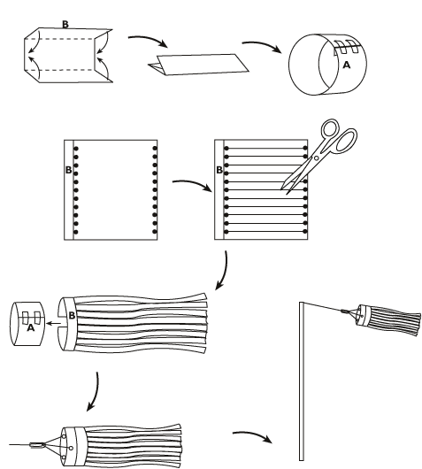

Project 6: Weather and our Animal Allies (Team 3)
Learning Goals: The children will be learning about the weather, in terms of understanding and measuring wind, rain, and temperature. For this final project, we will make the weather “real” by thinking about how our animal allies have survived the winter and what they now need to eat. The children will have opportunities to make observations, and record different kinds of information in their science notebooks.
Behavioral Goals: Children will observe a small, wild space in the city and observe their animal allies. They will observe and make hypotheses about the animals’ food needs at this time of year by thinking about the current weather conditions and predicting the weather conditions during two weeks. Children will draw and map and use words describing weather conditions.
Meeting 1 (Monday, April 4)
Today we will go the Bach Library, which is a short walk from the school. We will observe the Backyard Story Garden, which features old-growth Black Walnut trees. Tell the children our goal is to observe animals and think about where we could hang food garlands for them. If we can, we will go outside and sketch the layout of the garden or draw the trees in their science journals. We can do this indoors, as well. Children should be encouraged to identify what animals are here and what their food needs are. They should observe if there are food sources in the garden already. If animals are not to be seen, they should interview the librarians and ask what animals they have observed in the Backyard Story Garden. Children should write down animal names and record weather conditions in their science journal. Add a full date to the science journal.
Meeting 2 (Friday, April 8)
What wild animals have the children seen in the city? What do they eat? How do they survive through the winter and early spring? Now that it is warmer, what kinds of activities do the animals do? What are the weather conditions like today? Is there food available to the wild animals in the city now that it is warmer? Why? Today, back in the regular classroom, we will make food garlands for the animals. Help the children coat the dried bagels with pumpkin seed butter (this is not dangerous to a child with tree nut allergies and can be bought from a company that does not process tree nuts!) and roll them in birdseed and oatmeal. Help the children string popcorn, dried fruit and bagels on strings. As you do this, see what predictions the children can make about what animals may come to eat this feast.
Meeting 3 (Monday, April 11)
We will return to the Bach Library today and hang the food garlands. Encourage children to think about where the garlands should be placed based on what they have seen and what they know about animals’ abilities to climb, fly, or perch. The librarians should be consulted and all the adults will most likely do most of the hanging! However, encourage problem solving from the children! If there is time, we should retreat and observe. Sketches and information can be recorded in science journals. Add a full date to the journals.
Meeting 4 (Friday, April 15)
This is our big celebration day! We will look to see how much food was eaten and if any other events occurred in the Bach. In the community room we will all gather (hopefully our morning St. Rose teachers will attend as well) and enjoy food and drink together!

***
Sources for these projects, ideas that inspired them, and information about the basic knowledge of backyard science include:
Frank, M. S. (2002). Harcourt Science. New York: Harcourt School Publishers.
Monaghan, K. (2007). Organic crafts: 75 earth-friendly art activities. Chicago: Chicago Review Press.
Make a mini greenhouse from a CD case. (n.d.). Retrieved January 13, 2010, from
http://www.ecoliteracy.org/downloads/make-mini-greenhouse-cd-case
Make a windsock. (n.d.). Retrieved January 13, 2010, from
http://guidedtour.windpower.org/en/kids/choose/nacelle/wvassign.htm
Name that soil. (n.d.). Retrieved January 13, 2010, from
http://school.discoveryeducation.com/schooladventures/soil/name_soil.html
Sobel, D. (2008). Childhood and nature: Design principles for educators. Portland, Maine: Stenhouse
Publishers.
What is soil. (n.d.). Retrieved January 13, 2010, from
http://www.blogdivvy.com/growing-vegetables/what-is-soil.htm
. . . and The Shambles Organic Gardens in Pomfret, Vermont

Notes about projects after they were conducted:
We found that the sand/glue mixture took about two months to fully cure! You can do another activity on day two of the fossil activity and leave the fossils for a good long while for a treat later in the month!
We found that the children did not enjoy using their science journal as much as doing the activities. Drawing in the journal or on other paper and labeling is great fun—writing is not as much fun. Rethink the uses of the science journal.
We had 5-10 books (informational and fictional) related to each topic as well as digital audio recorders available for each day. These were used as teachers saw fit.

